Creating a node server in domainracer:

1. Click on ‘Setup Node js App’  
     
   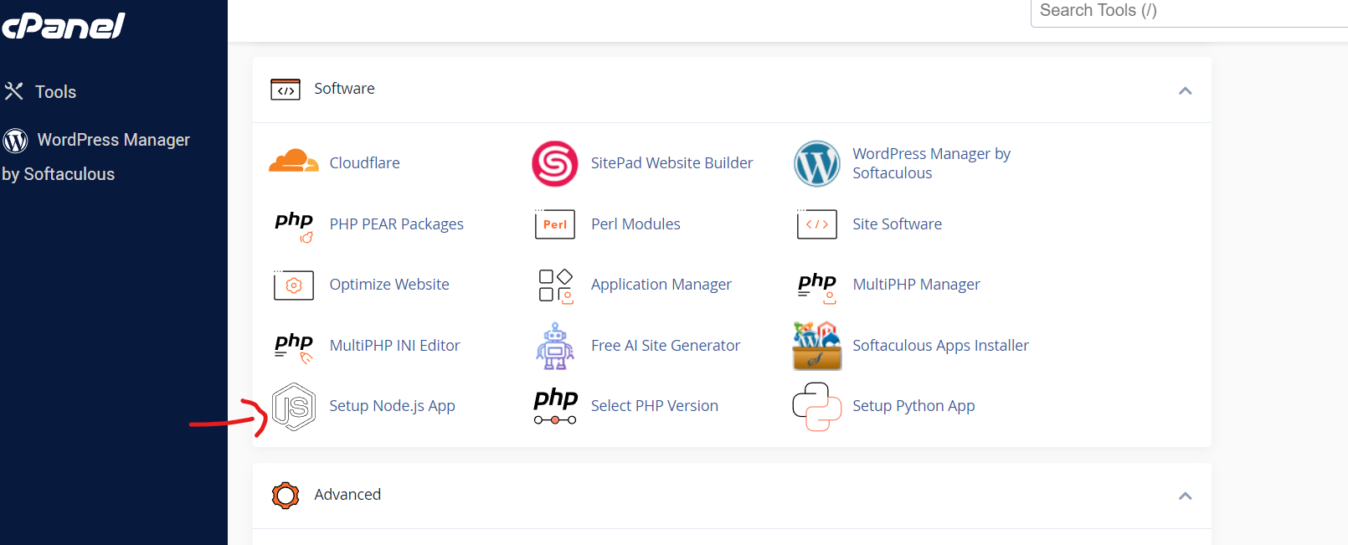
2. Click on ‘Create Application’  
     
   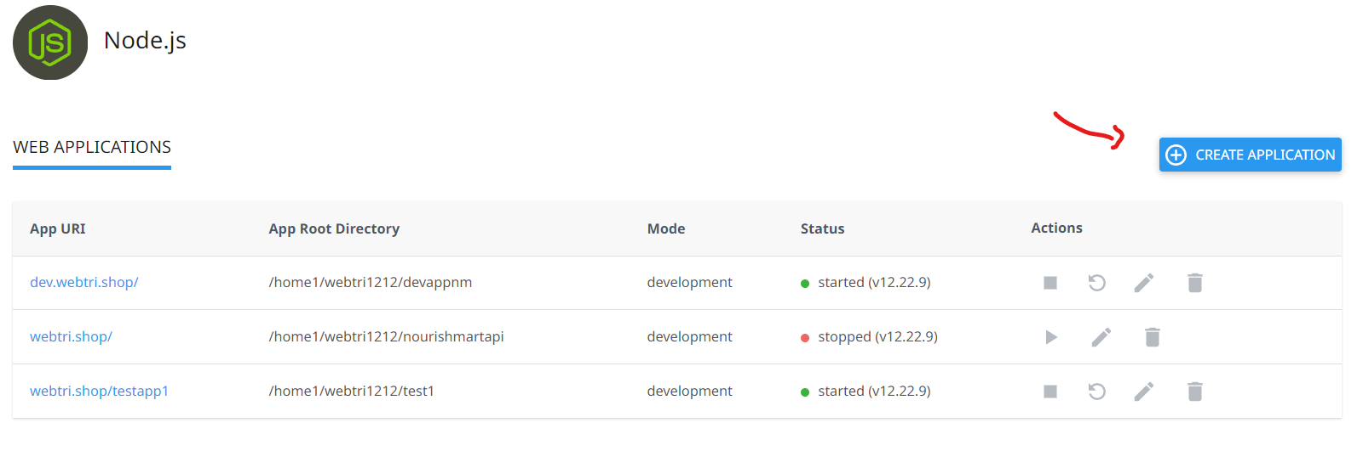
3. Specify a name in the application root. This will be the folder in which the node files will be placed. Leave the application url blank but select the domain for which the app needs to be placed. (Specifying a path in application url is not working as of now, hence just using the root path ‘/’ by default for now). Repeat this for different environments.  
     
   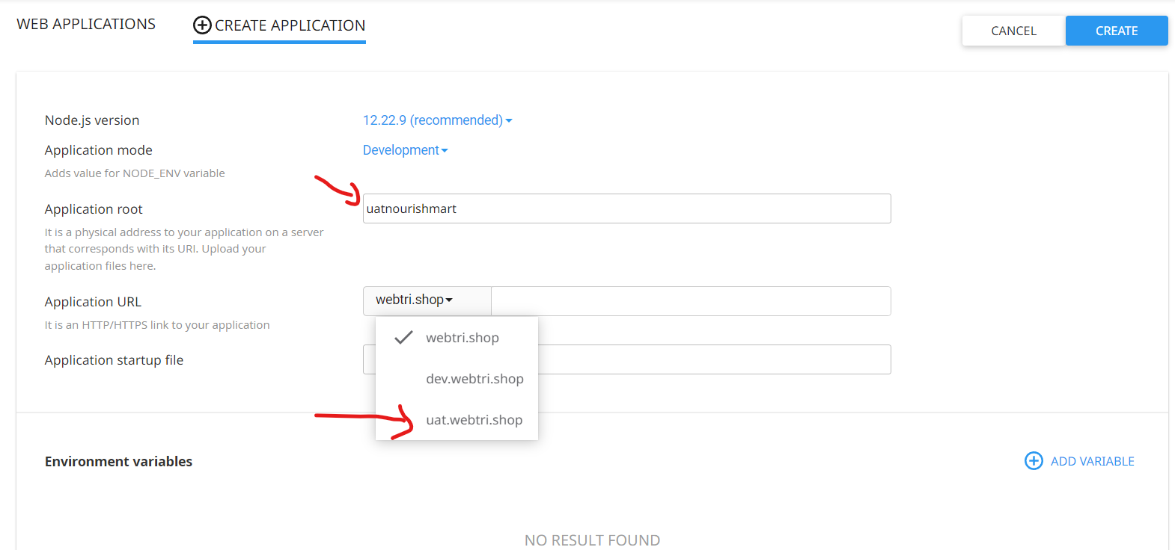
4. Select the node js version and add the startup file name from which the app gets triggered. Now click on ‘create app’. Click on ‘Open’  
   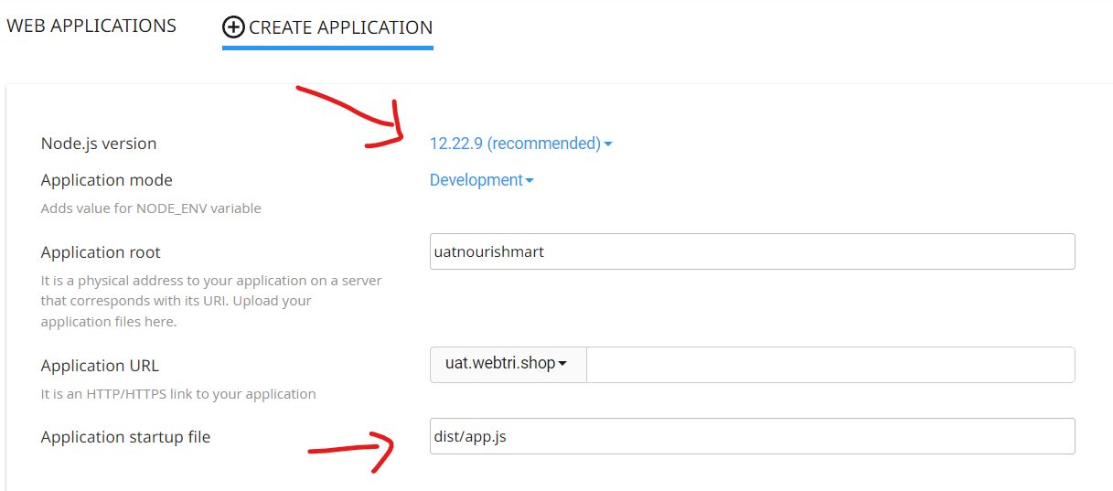  
     
   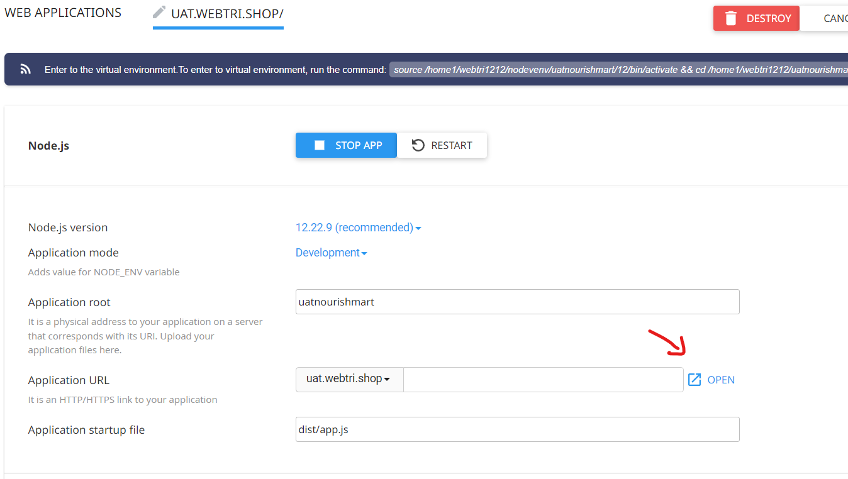  
     
   When opened you should see this. This indicated node app is properly configured.  
   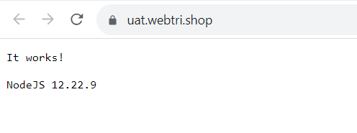
5. Go to cpanel -> file manager. You should now see the uat.webtri.shop sub domain and the folder caller ‘uatnourishmart’ created. ‘uatnourishmart’ is the name that we mentioned in application root text box while creating the node app.  
   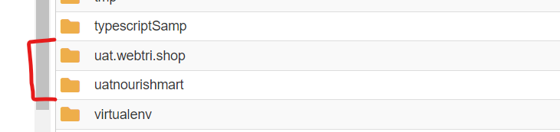
6. Enter into ‘uatnourishmart’ folder and place the package.json file. This package json file should have all the package names to be installed.  
   sample code:  
   {

"name": "nourishmart",

"version": "1.0.0",

"description": "",

"main": "app.ts",

"scripts": {

"start": "app.js"

},

"keywords": [],

"author": "",

"license": "ISC",

"dependencies": {

"@types/body-parser": "^1.19.2",

"@types/express": "^4.17.17",

"@types/mysql": "^2.15.21",

"@types/node": "^20.5.4",

"body-parser": "^1.20.2",

"cors": "^2.8.5",

"dotenv": "^16.3.1",

"express": "^4.18.2",

"mysql": "^2.18.1",

"nodemon": "^3.0.1",

"sequelize": "^6.32.1"

},

"devDependencies": {

"@types/cors": "^2.8.13",

"typescript": "^5.1.6"

}

}

1. Once you place the file go the node app setup and now the ‘Run NPM install’ button will be enabled. Click on it to install.  
   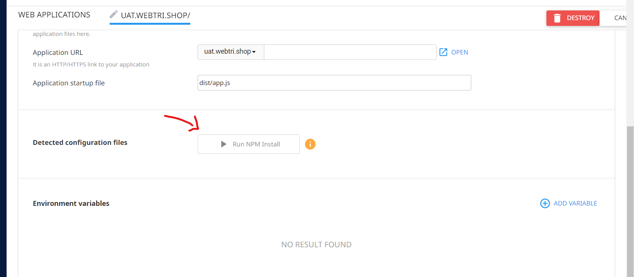
2. Build the file for deployment using command tsc –build  
   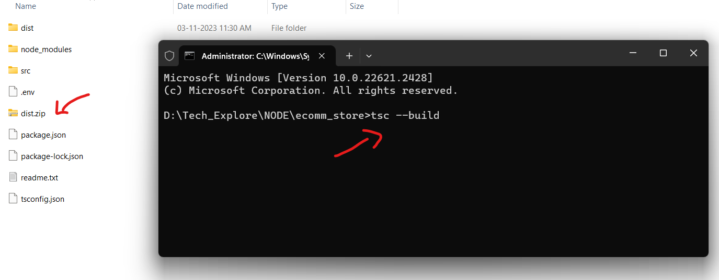
3. Enter into ‘uatnourishmart’ folder and upload the dist folder and extract it